Management Team Building and Collaboration
Name
Institutional Affiliation

Management Team Building and Collaboration
Introduction
Management team building at workplaces are increasingly becoming significant due to globalization, its primary objective being to facilitate productivity and work effectiveness and efficiency. Working in an organization that has distributed management team is a collaborative task that, if not done appropriately, will hamper performance. One possible reason behind poor work efficiency and productivity is that most of the management teams received inappropriate training required to function effectively (Roberts et al., 2008). Management team building is particularly necessary and essential when the teams face challenges of infective team meetings, hostility, and conflict among the members of the group, increasing complaints from the management team members, low output or productivity as well as the decisions which are not carried out appropriately or misunderstood. However, team building training is increasing becoming time-consuming and expensive due to an increase in globalization across the world. The distribution of management teams needs new communication strategies through new techniques and channels (Rice et al., 2007). As a result, most researchers and scholars are exploring different team building, and collaboration sessions through the use of various modes of communication as the management teams have a smaller number of opportunities in the current business environments to interact face-to-face. Because face-to-face team meetings, the traditional as well as a consistently used technique for the various activities of team building, are time-consuming and costly in globally distributed business entities such as the multinational companies, virtual meetings have become increasingly utilized. But the present 2D online meeting tools might not enhance togetherness and proximity sense important for carrying out tasks in a management team.
As a consequence, virtual worlds such as interactive three-dimensional software computer-based environments, are increasingly receiving attention. In the virtual world environment, several users usually interact simultaneously with each other through different avatars in immersive, simulated multimedia business environments. Even though there are many kinds of virtual worlds, like Active Worlds and Second Life (SL), all contain six components which support communication and collaboration of the management team members: community/socialization, persistence, interactivity, immediacy, graphical user interface, and shared space (Kelly &Cheek, 2008). Since the research in the virtual worlds is limited, the most analysis being carried out in the fields of distance education and gaming. To extend the research on virtual worlds into fields of team-building and collaboration, this papers proposes to explore three modalities of communication, the Second Life(SL) virtual world, traditional face-to-face space meeting as well as the combination of the virtual world and face-to-face space meeting.
Team- Building
The management team –building concept emerged during the Hawthorne studies carried out in the 1920s in Cicero, Illinois at Western Hawthorne organization. These studies were carried by Professor Mayo Elton of Harvard University to evaluate the effect of various work environments on work effectiveness and productivity. One most significant finds of the experiments was that of social cohesion and support feelings, group identity sense which usually comes with high levels of employee interaction leading to increased productivity and works efficiently. At the start of 1950s the study in team-building was expanded to explore self-directed management teams, majorly focusing on the automobile companies such as the General Motors, its effectiveness and success inspiring various business organizations like Pratt and Whitney, Volvo, Xerox, and Honeywell to implement and adopt the same strategy(“ The Hawthorne Effects”,2009).
During the 1980s era, most research started to focus mainly on the multi-cultural management team-building. Roberts et al. (2003) state that management team-building in various circumstances eases tension between internal team growth and development and external differences. According to Kelly &Cheek (2008) setting up a teaming-building environment requires continuous efforts and techniques to monitor the ability of the team members to implement different actions designed the increase the work effectiveness, productivity as well as team performance. Kelly &Cheek (2008) further noted that a competent management team should have clear overall objectives and goals as well as appropriate member qualifications, leadership, and resources to attain them.
According to Roberts et al. (2003), cross-cultural management teams often enhance diversity in the workplace, since these type of groups have multiple sets of skills which no person possesses. The advantages of these combined skill-sets have increasingly become crucial and complex. There are various components to be considered while establishing an effective management team-building as such the follow up of the task, focus structure, and the personal role of the timeline. Thus, for team-building to efficient and effective in improving work effectiveness and performance, it requires to be incorporated with appropriate training skills. Similarly, Rice et al. (2007) describe different essential components needed by the management teams to perform their tasks more efficiently: a common objective or identity, history, structure, and independence. These fundamental components form the goals and basis which will assist the team members to bond as well as build trust, creating team interdependency. This vital sense of unity can only be attained through team-training emphasis for increasing effective communication across the culturally diverse management teams.
According to McNeese et al. (2008) who describes the group development model established by Trackman, management team involves the following five stages:
(a).Forming: This consists of the team members meeting the first time
(b).Storming: Involves addressing the differences of the team members regarding perceptions, personal agendas, culture, and communication styles
(c).Norming: In this stage the team members start to identify themselves as a management team, learning to perform the project tasks together more effectively.
(d).Performing: In this group development stage, the team members become increasingly productive, able to communicate, as well as effectively solve problems and make decisions jointly.
(e).Adjourning: in this stage, the management team members usually reach the point of closure and transition back to their various places of work.
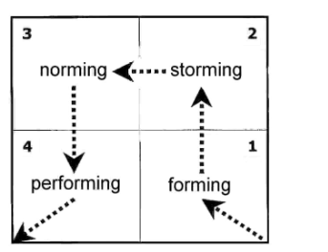
Figure A: Trackman’s Team development Model (McNeese et al., 2008)
Team Collaboration
Since the present internal and external business environments, collaboration among the culturally diverse management teams has increasingly become more critical, particularly for global business institutions; as a consequence, most researchers and scholars have explored different techniques for facilitating team performance and communication. For instance, Roberts et al. (2008) describe the electronically enabled meeting techniques of dispersed-asynchronous, dispersed –synchronous, and face-to-face comparing the behavioral aspects such as socio-technical dimensions regarding time and quality of participation, coordination competence, leadership effectiveness, and cohesion. This indicates that there is much difference in social presence, coherence, and performance among the meeting modes of team members, but co-ordination and leadership were considered better in the face-to-face spaces. In my current workplace for instance at one of the branches of Amazon company which is a multinational company involves both computer conferencing (CC) as well as face-to-face (FF) techniques of communication by using various system designs tasks, which focuses on the progress and performance of different management teams working in the company. Computer conferencing tend to enhance the creation of better and efficient decisions because of the increase in the number of participants, more in-depth analysis, the broader range of opinions and ideas, as well as a lot of opportunities for handling assessment of the project more appropriately as compared to FF (face-to-face).

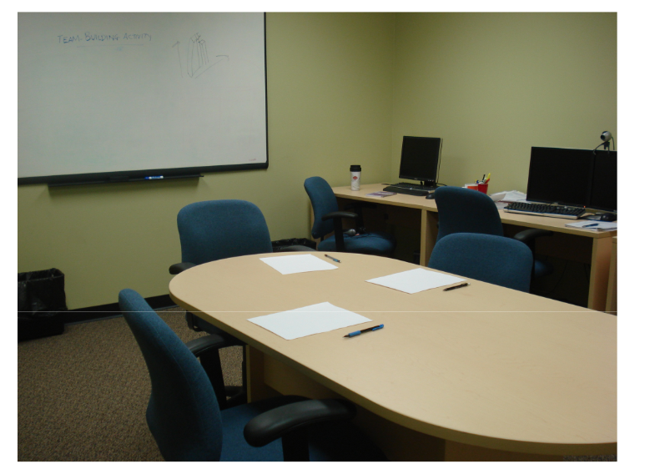
Figure B: face-to-face meeting space
The use of Virtual Worlds in team-building and collaboration
Technological advancement has made team building and collaboration more effective and efficient. According to Kelly & Cheek (2008), virtual worlds are usually multimedia, immersive, and simulated environments accessed through the use of computer networks. In the few decades, virtual worlds have been utilized in entertainment like gaming, and education. Currently, the virtual worlds such the three-dimensional virtual worlds as well as the Second Life (SL) virtual world have increasingly become applied in several fields. According to McNeese et al. (2008) describes how the three-dimension virtual worlds have also become more popular social platform which is often beyond the required to win or play games. There is a various current realistic business environment like hotels, gardens, tropical highland, and other tourist appealing places the virtual world users can visit as well as enjoy. Together with several socialization, these type of business environments has increasingly become a significant commercial platform in which the individuals engage in various business ventures with large business organizations like Amazon, Apple, Nike, and Coca-Cola marketing their commodities.
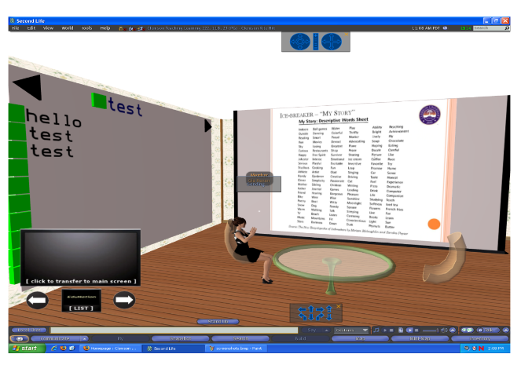
Figure C: Second Life (SL) Virtual worlds meeting space
Conclusion
The effectiveness of the team building and collaboration space, whether virtual world or face-to-face (FF) usually depends on two elements: technological resources required to carry out the projects more efficiently and effectively, and the location of the management team members. The primary components of face-to-face meeting spaces are travel cost and travel time. If the management team members are situated in the same location geographically, then the travel time and cost will not usually be necessary. But with an increased number of employees with cultural diversity distributed in various parts of the world in the case of the multinational companies travel cost and travel time factors increasingly become significant.
On the other hand, the most crucial component for the virtual world meeting spaces is the technological costs to establish it. The resources needed for setting up the Second Life (SL) virtual world meeting spaces for instance includes the cost of buying computers and other equipment for each management team member , the meeting spaces in the Second Life(SL) or the 3D virtual world as well as the cost of maintenance for any type of software tools and machines. Therefore, to establish appropriate team –building and collaboration within the business organization like Amazon Company the management should establish combine both the traditional face-to-face meeting spaces and the virtual world such as the Second Life (Life) as well as the 3D virtual worlds to improve work effectiveness and productivity of the team members.

References
The Hawthorne effect - Mayo studies in employee motivation (2009). Retrieved December 14, 2018, from http://www.envisionsoftware.com/articles/Hawthorne_Effect.html.
Kelly, H., & Cheek, D. (2008). Designing an online virtual world for learning and Training. Paper at the 2008 5th IEEE International Conference on Wireless, Mobile and
Ubiquitous Technology in Education, 208-9.
McNeese, N., Pfaff, M., Santoro, G., & & McNeese, M. (2008). Team performance in real and virtual worlds: The perceived value of second life. In Proceedings of the Human Factors and Ergonomics Society 52nd Annual Meeting, Santa Monica. 1435-1439.
Rice, D. J., Davidson, B. D., Dannenhoffer, J. F., & Gay, G. K. (2007). Improving the
effectiveness of virtual teams by adapting team processes. Computer Supported Cooperative
Work: An International Journal, 16(6), 567-594. Retrieved from http://dx.doi.org/10.1007/s10606-007-9070-3.
Roberts, D., Wolff, R., Otto, O., & Steed, A. (2003). Constructing a gazebo: Supporting teamwork in a tightly coupled, distributed task in virtual reality. Presence, 12(6), 644-57. Retrieved from http://dx.doi.org/10.1162/105474603322955932.

